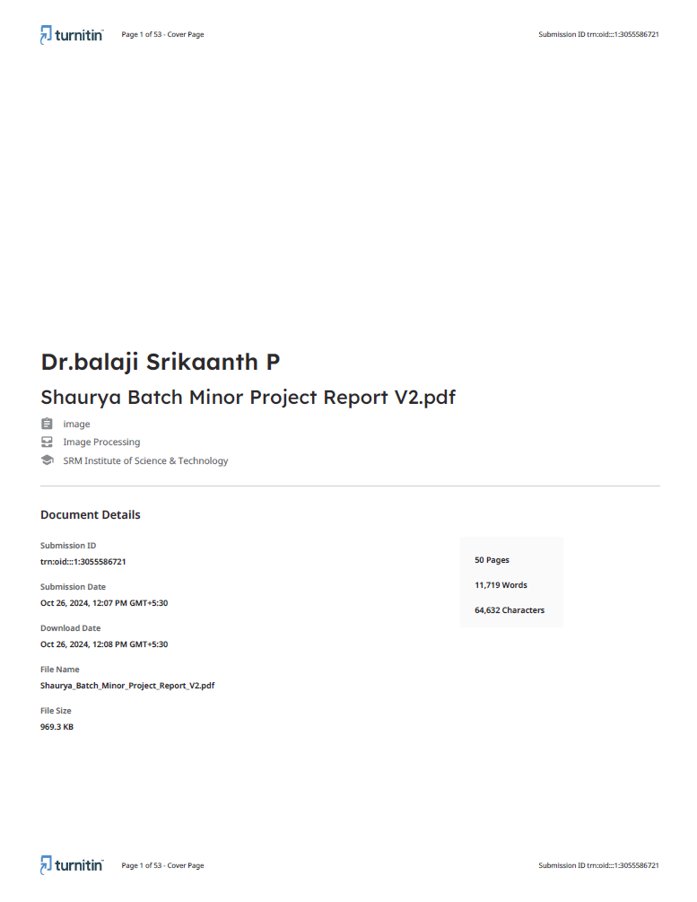

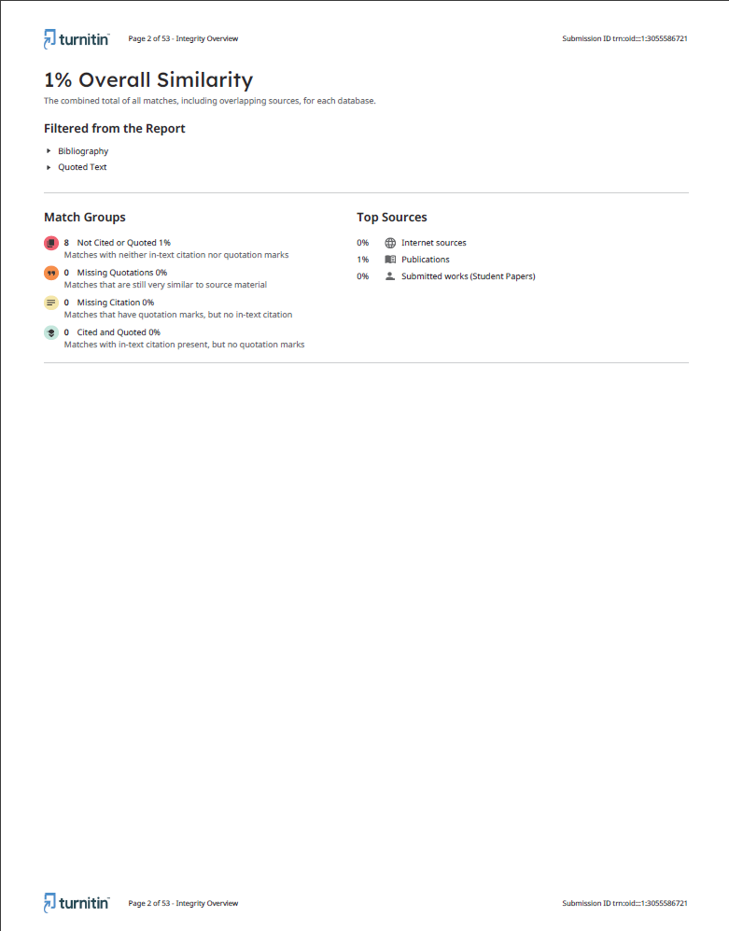

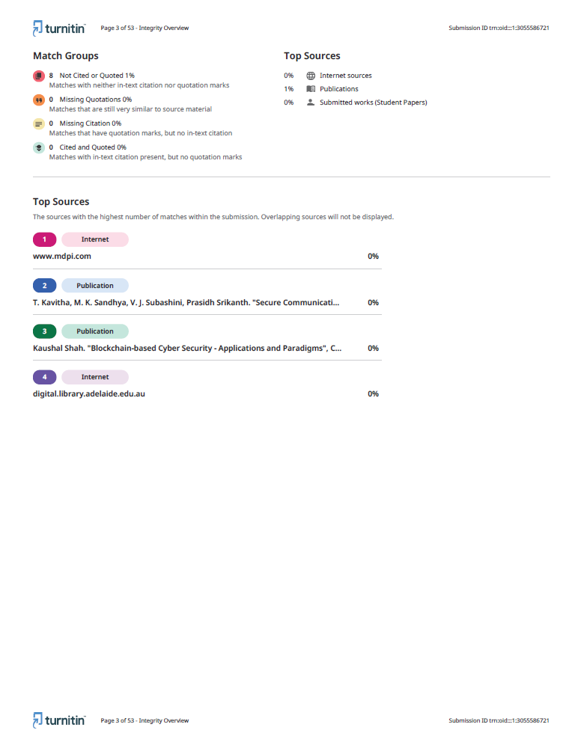

**PLAGIARISM REPORT**

Format – I

|  |  |  |
| --- | --- | --- |
| S R M I N S T I T U T E O F S C I E N C E A N D T E C H N O L O G Y  **(Deemed to be University u/ s 3 of UGC Act, 1956)** | | |
| **Office of Controller of Examinations** | | |
| REPORT FOR PLAGIARISM CHECK ON THE DISSERTATION/PROJECT REPORTS FOR UG/PG PROGRAMMES  **(To be attached in the dissertation/ project report)** | | |
| 1 | Name of the Candidate **(IN BLOCK LETTERS)** | SHAURYA SINGH SRINET |
| 2 | Address of the Candidate | B209, B Block, SIS SAFAA Apartments, GST Road,  Guduvanchery, Tamil Nadu - 603202 |
| 3 | Registration Number | RA2111032010006 |
| 4 | Date of Birth | 02-10-2003 |
| 5 | Department | Networking and Communications |
| 6 | Faculty | Engineering and Technology, School of Computing |
| 7 | Title of the Dissertation/Project | AI-Driven Dynamic Fuzz Testing for IoT Security |
| 8 | Whether the above project /dissertation is done by | 1. 3 Students have done the above project/dissertation. 2. SHAURYA SINGH SRINET (RA2111032010006) SHOUNAK CHANDRA (RA2111032010026) CHARVI JAIN  (RA2111047010113) : |
| 9 | Name and address of the Supervisor / Guide | **Name:** Dr. Balaji Srikaanth P.  **Mail ID:** balajis7@srmist.edu.in  **Mobile Number:** +91 9751009897 |
| 10 | Name and address of Co-Supervisor / Co- Guide (if any) | **Name:** Dr. Nagendra Prabhu S.  **Mail ID:** nagendrs@srmist.edu.in  **Mobile Number:** +91 7548844997 |

|  |  |  |  |  |
| --- | --- | --- | --- | --- |
| 11 | Software Used | Turnitin | | |
| 12 | Date of Verification | 26 October 2024 | | |
| 13 | **Plagiarism Details: (to attach the final report from the software)** | | | |
| **Chapter** | **Title of the Chapter** | **Percentage of similarity index (including self**  **citation)** | **Percentage of similarity index (Excluding self-citation)** | **% of plagiarism after excluding Quotes, Bibliography, etc.,** |
| 1 | Introduction |  |  |  |
| 2 | Literature Survey |  |  |  |
| 3 | System Architecture and Design |  |  |  |
| 4 | Methodology |  |  |  |
| 5 | Coding and Testing |  |  |  |
| 6 | Results and Discussion |  |  |  |
| **7** | Conclusion and Future References |  |  |  |
| **Appendices** | |  |  |  |
| We declare that the above information has been verified and found true to the best of our knowledge. | | | | |
| **Signature of the Candidate** | | **Name & Signature of the Staff  (Who uses the plagiarism check software)** | | |
| **Name & Signature of the Supervisor/ Guide** | | **Name & Signature of the  Co-Supervisor/Co-Guide** | | |
| **Name & Signature of the HOD** | | | | |